<https://interview.brainmeasures.com/>

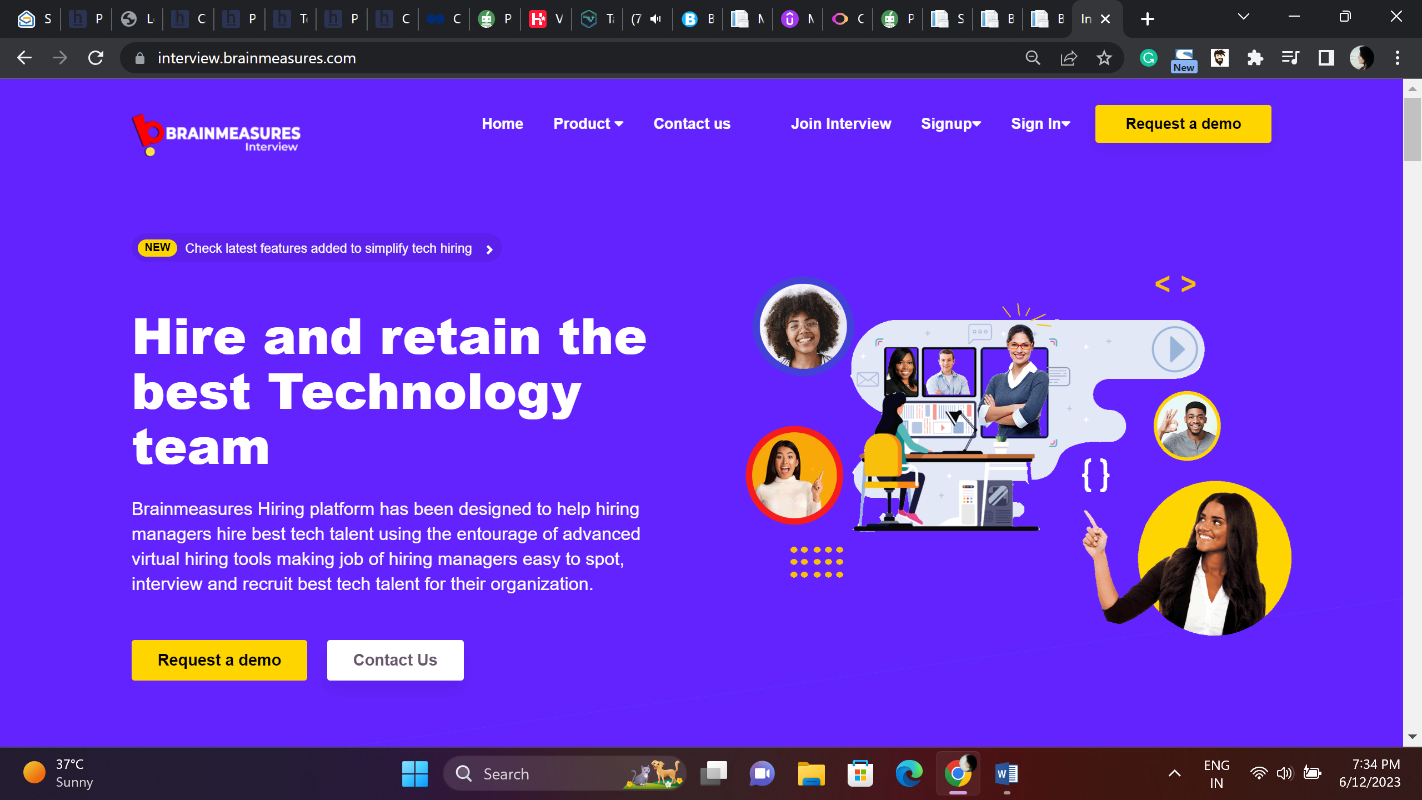

This content is OK

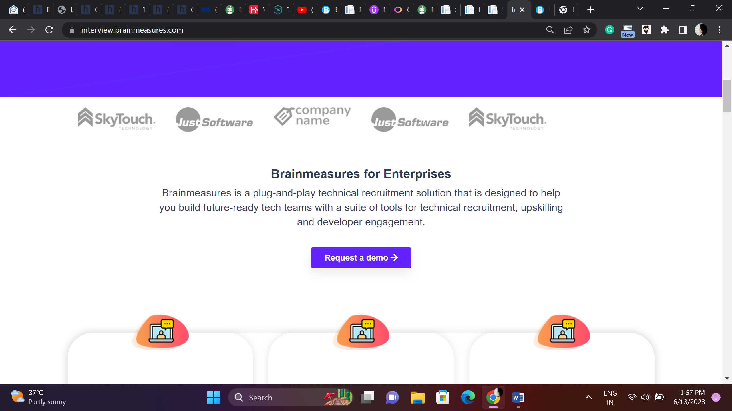

Brainmeasures provides technically advanced, seamless convenient recruitment solutions specifically designed to help recruiters and hiring mangers build future-ready tech teams. Brainmeasures has a wide range of tools for recruitment, Upskilling teams that meet your organizational goals and vision.

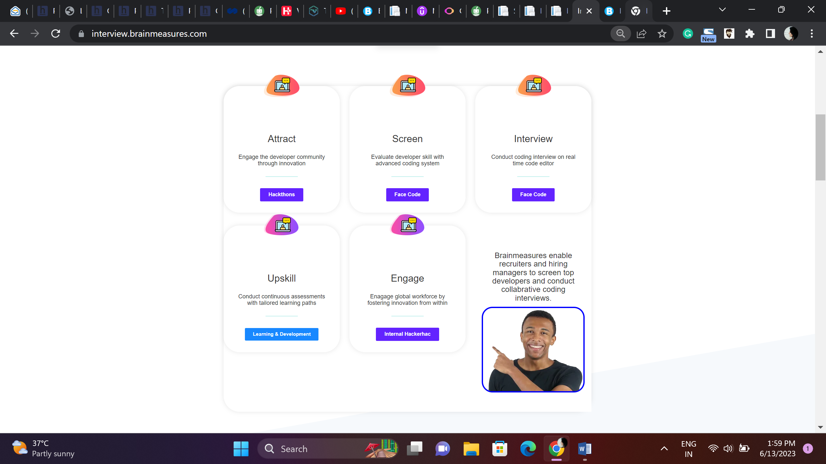

Attract

Attract right talent by engaging young, enthusiastic developer community.

Screen

Screen and evaluate candidate skills using ML and AI based advanced coding platform.

Interview

Conduct real time interviews, simultaneously interview multiple candidates, use code editor and hire best talent for your organizations.

Upskill

Retain and develop your teams using Brainmeasures huge repository of learning resources.

Engage

An online platform, engage global talent and build teams that will help you excel

**Brainmeasures enables recruiters and hiring managers to screen top developers and conduct collaborative coding interviews.**

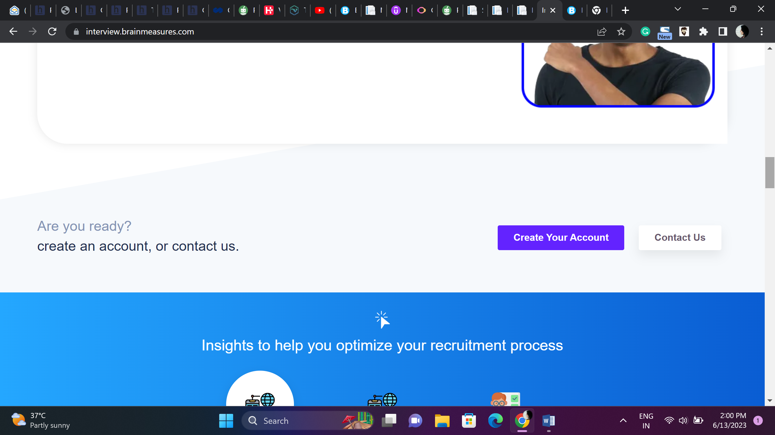

This content is OK  
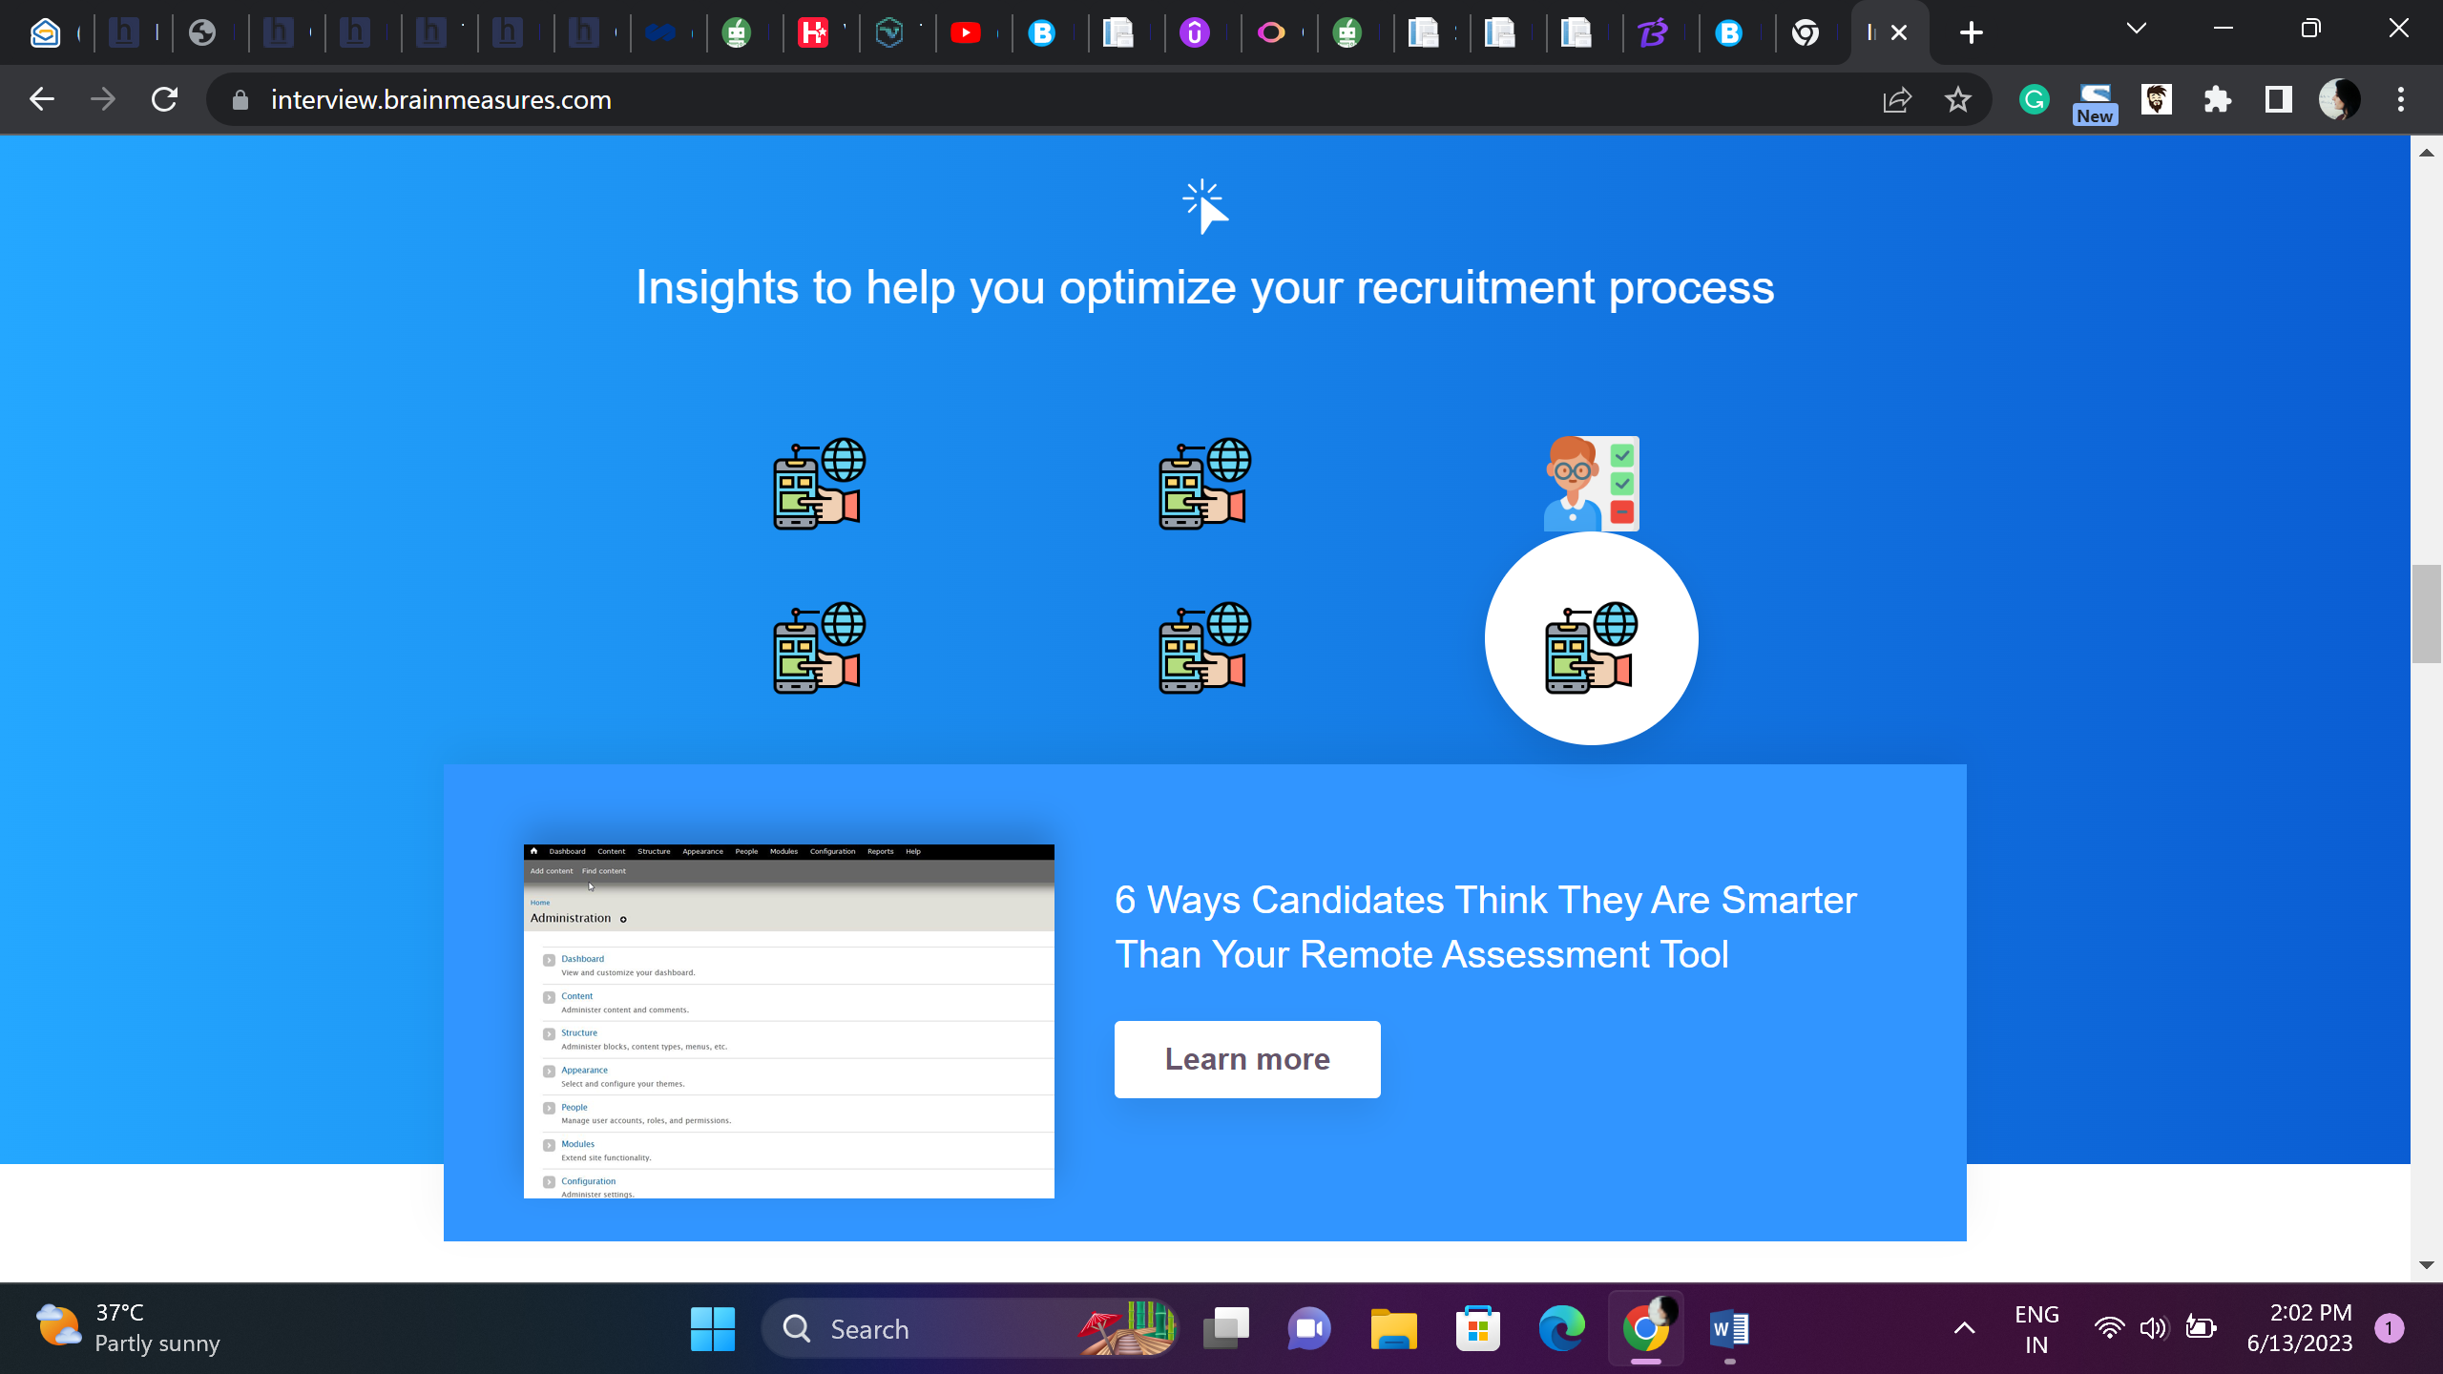

Experience Power of AI and ML and optimize your recruitment process.

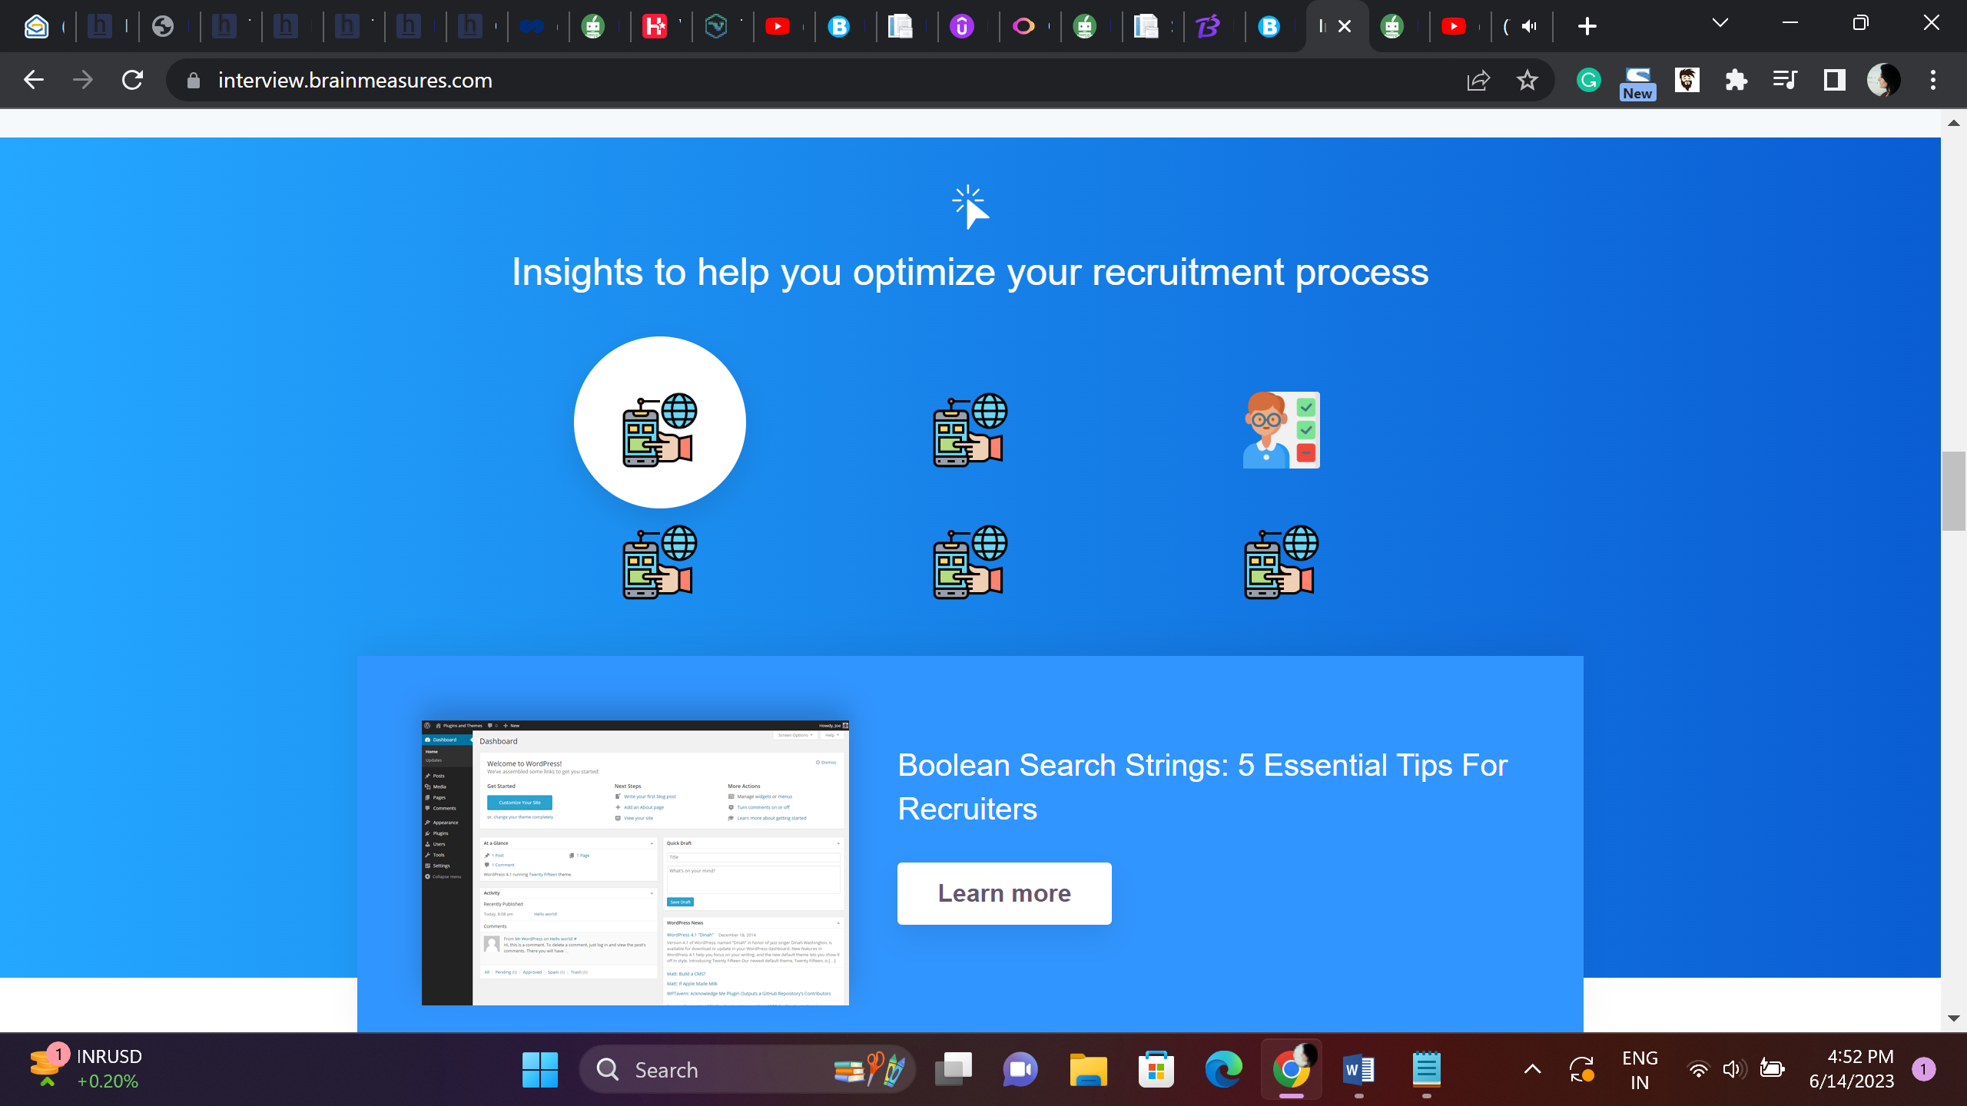Getting the recruitment process right – Tips for Hiring Managers

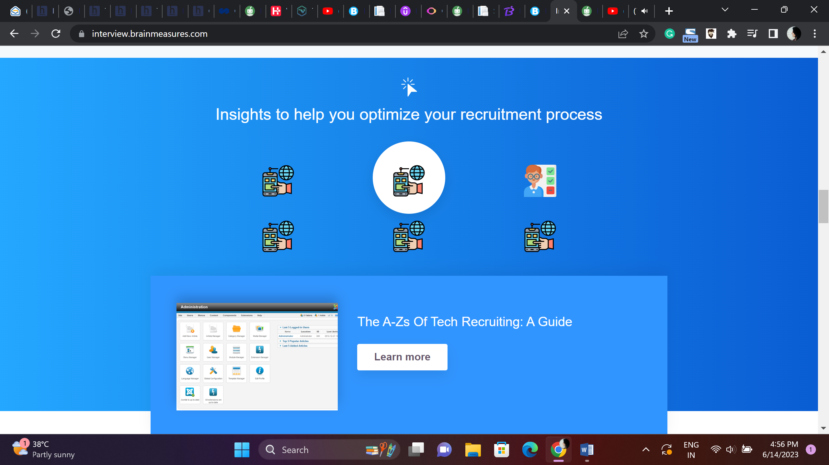

Get your recruitment process right – Guide to Tech Recruiting

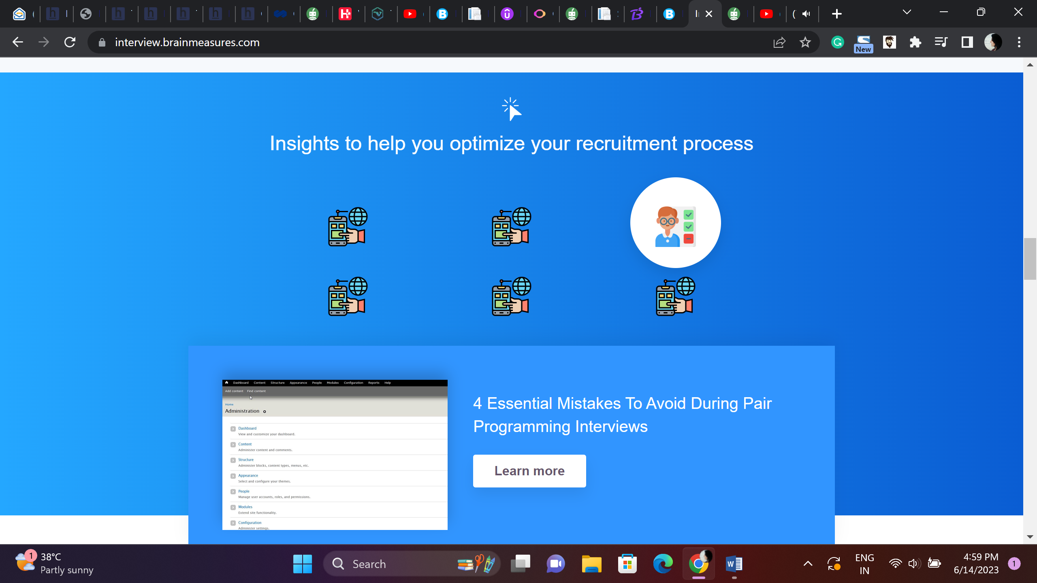

Pair Programming Interviews – All you need to know

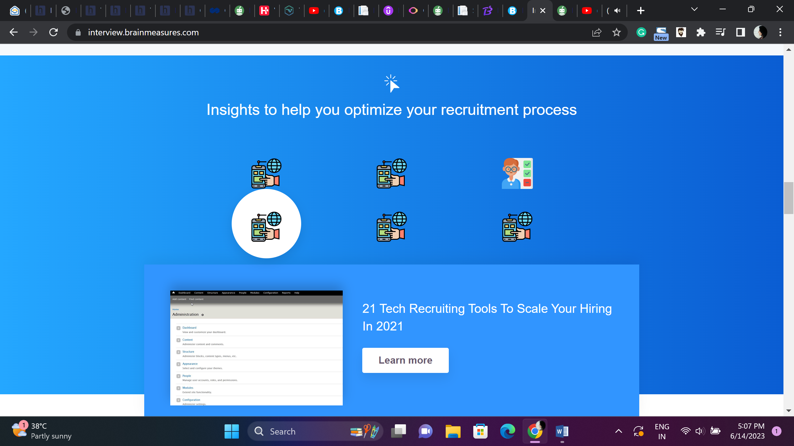

Complete suite of Tech recruiting tools – Boost your Hiring Process

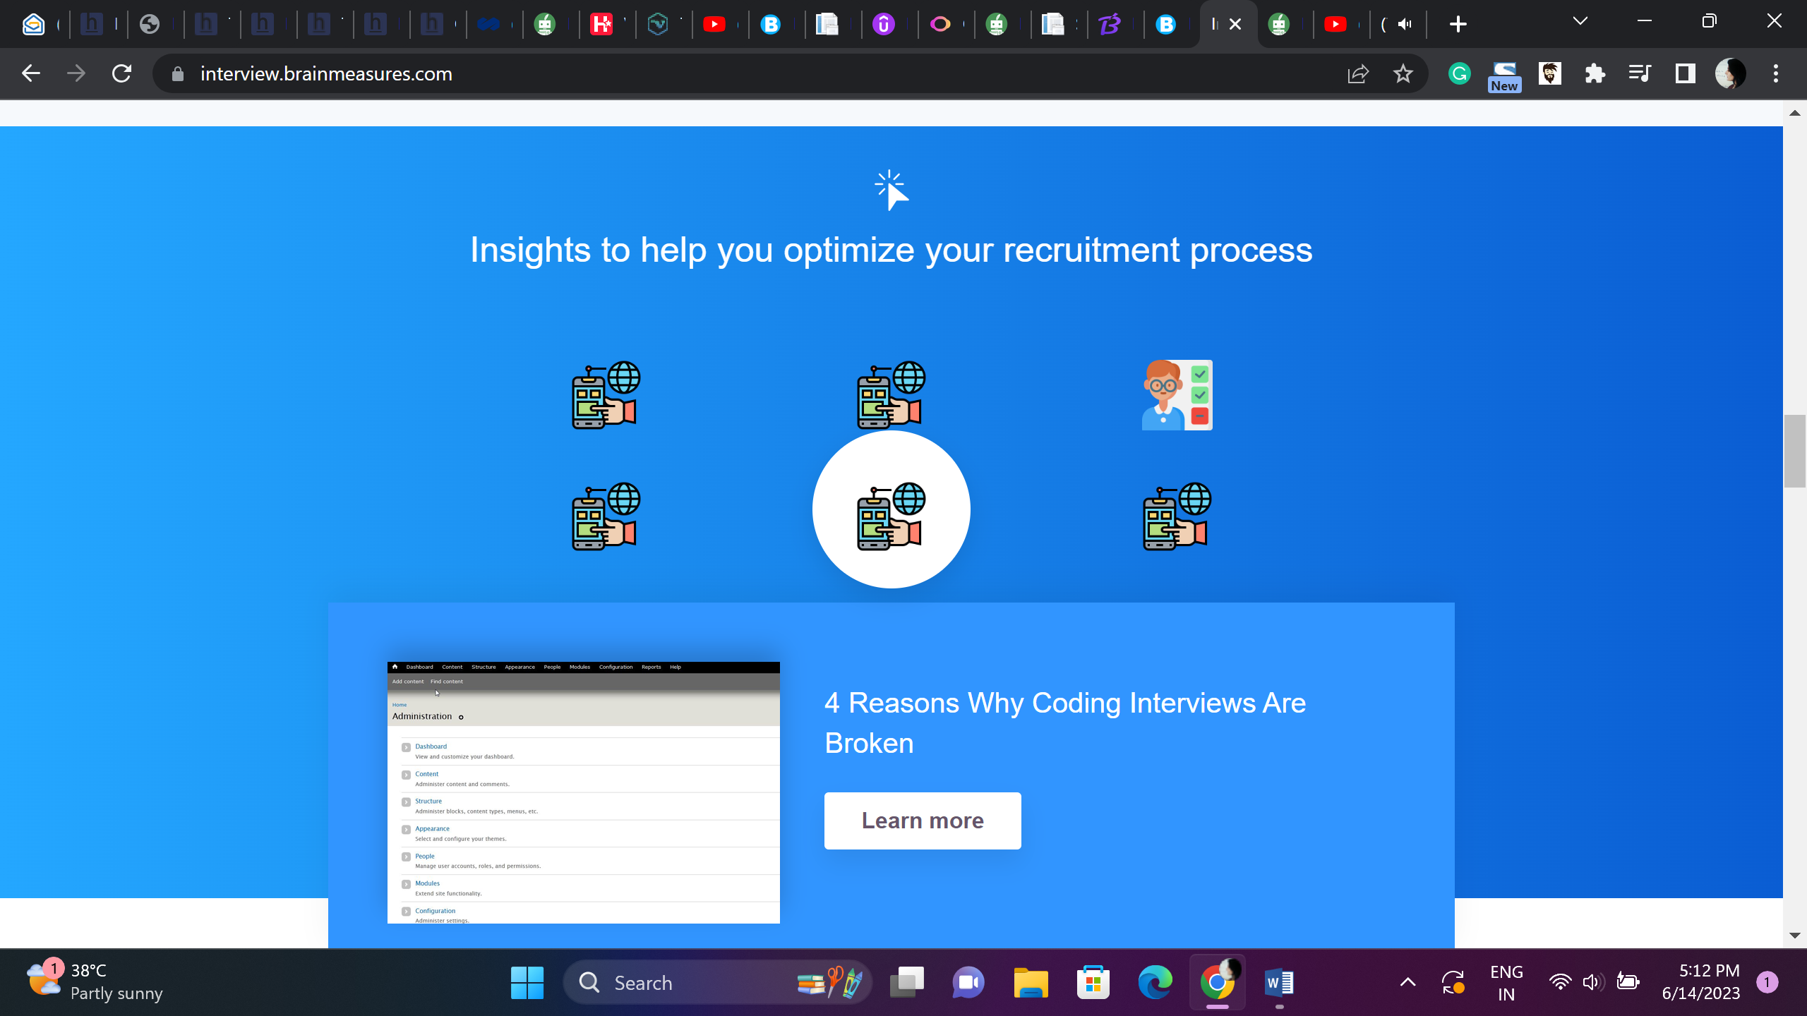

Coding Interviews – Dos and Donts

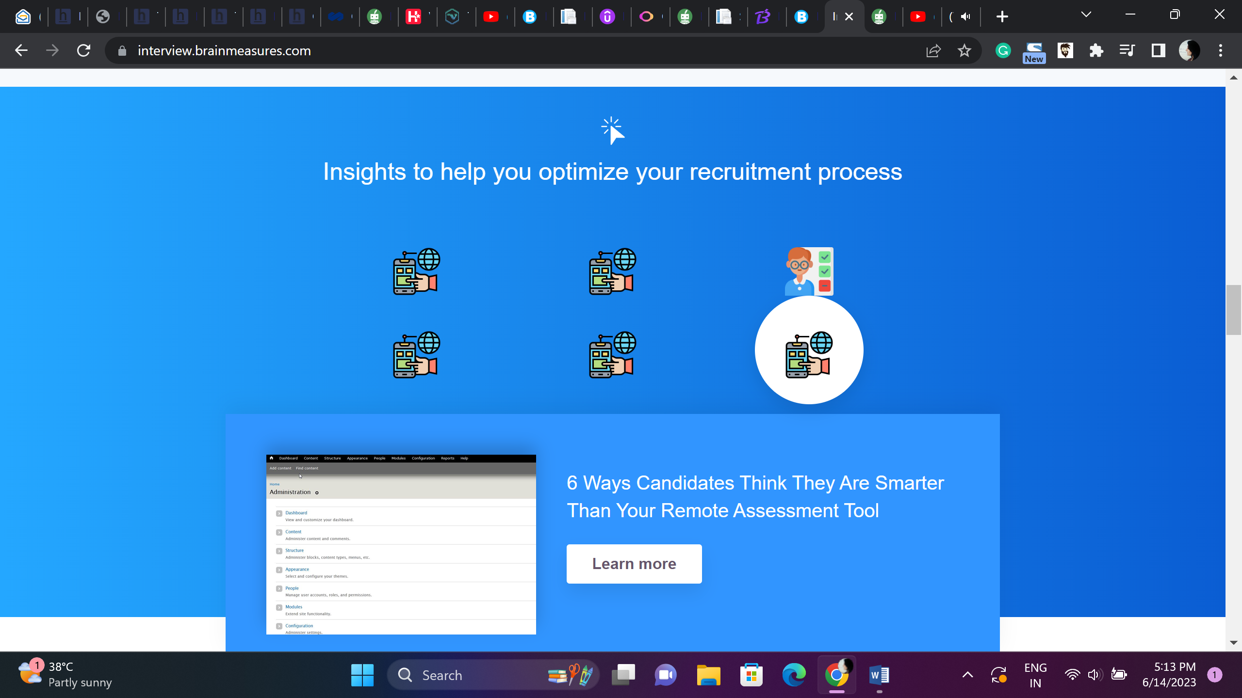

Remote Assessment Tools – Choosing Right Talent for your organization

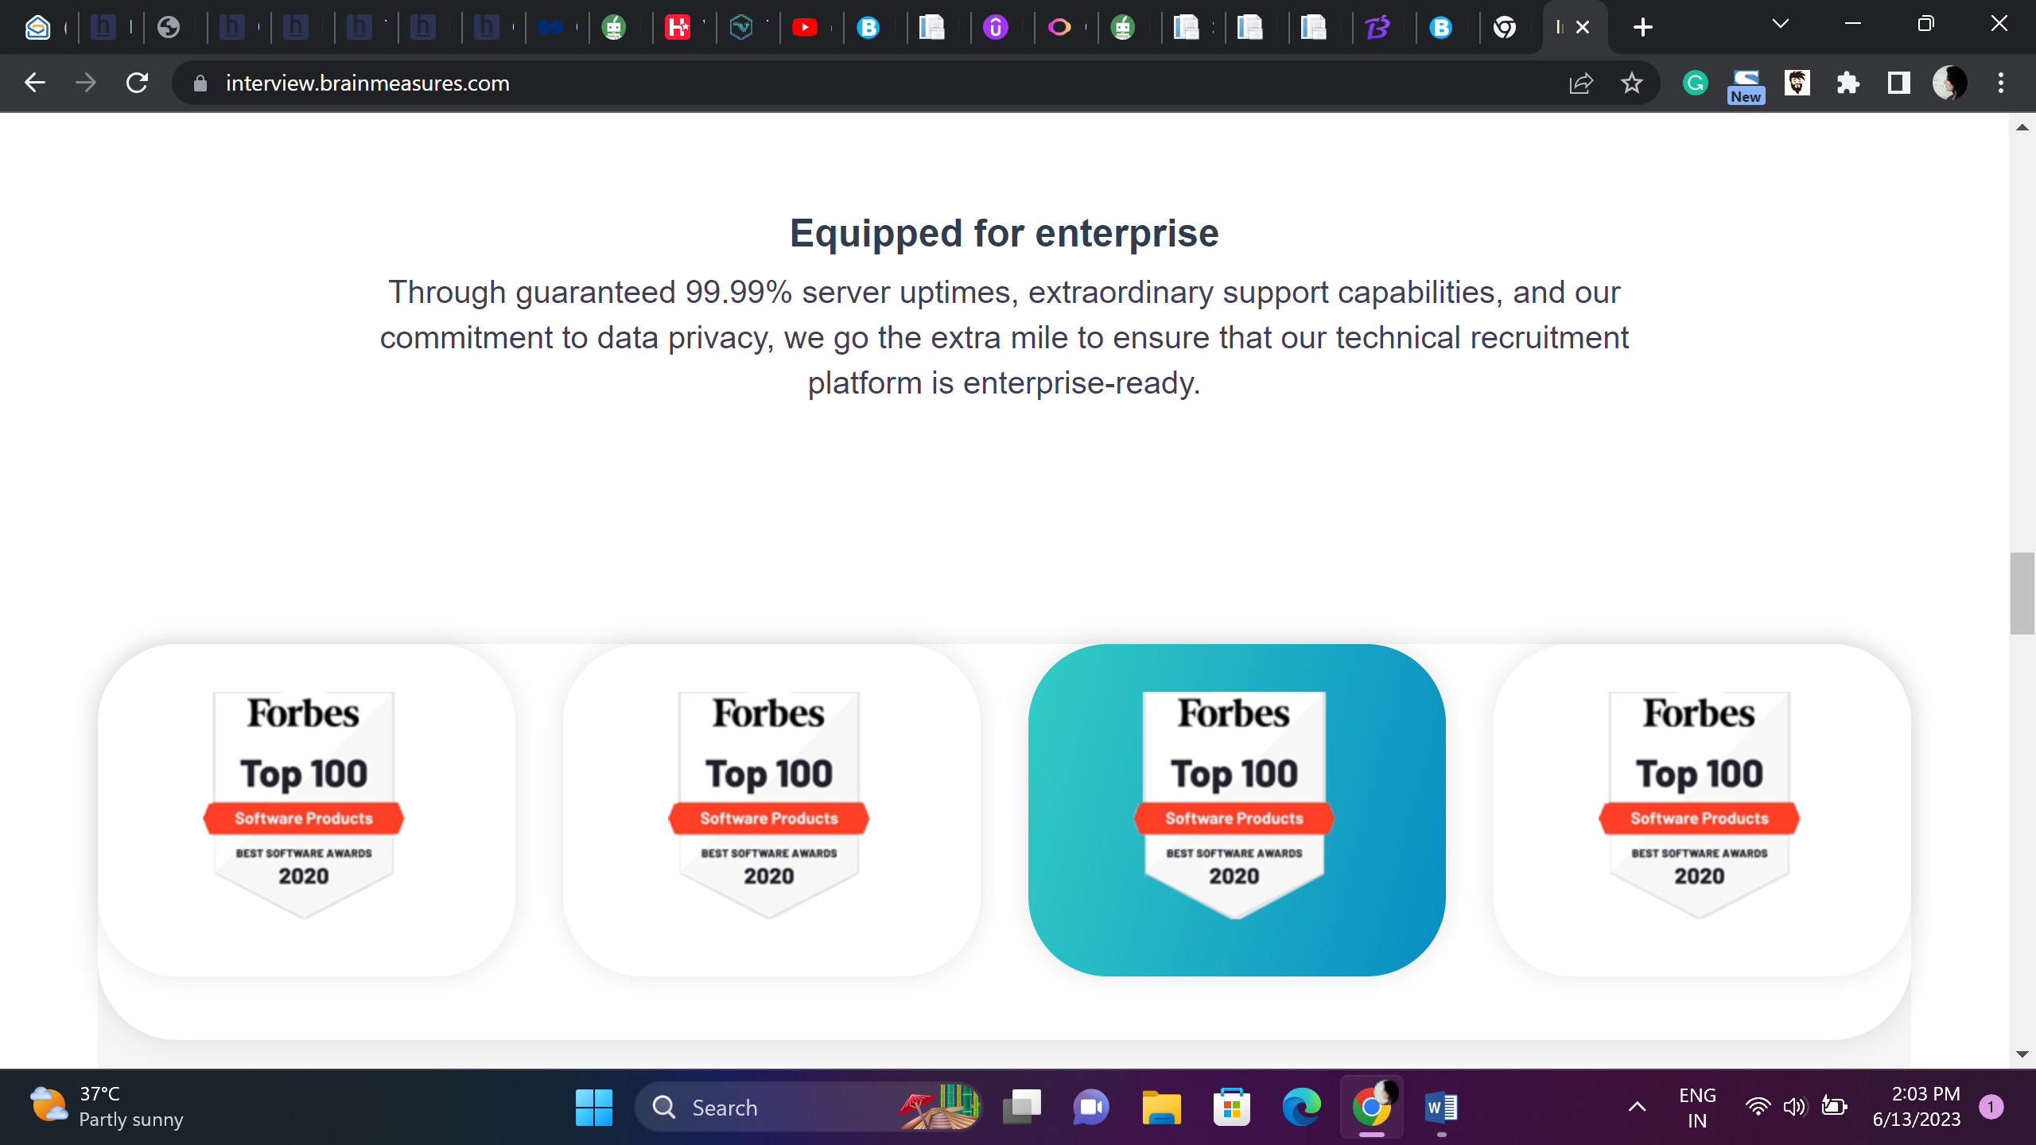

Enterprise Ready Platform

We go above and above to make sure that our technical recruitment platform is enterprise-ready, providing guaranteed 99.99% server uptimes, exceptional support capabilities, and a dedication to data protection.

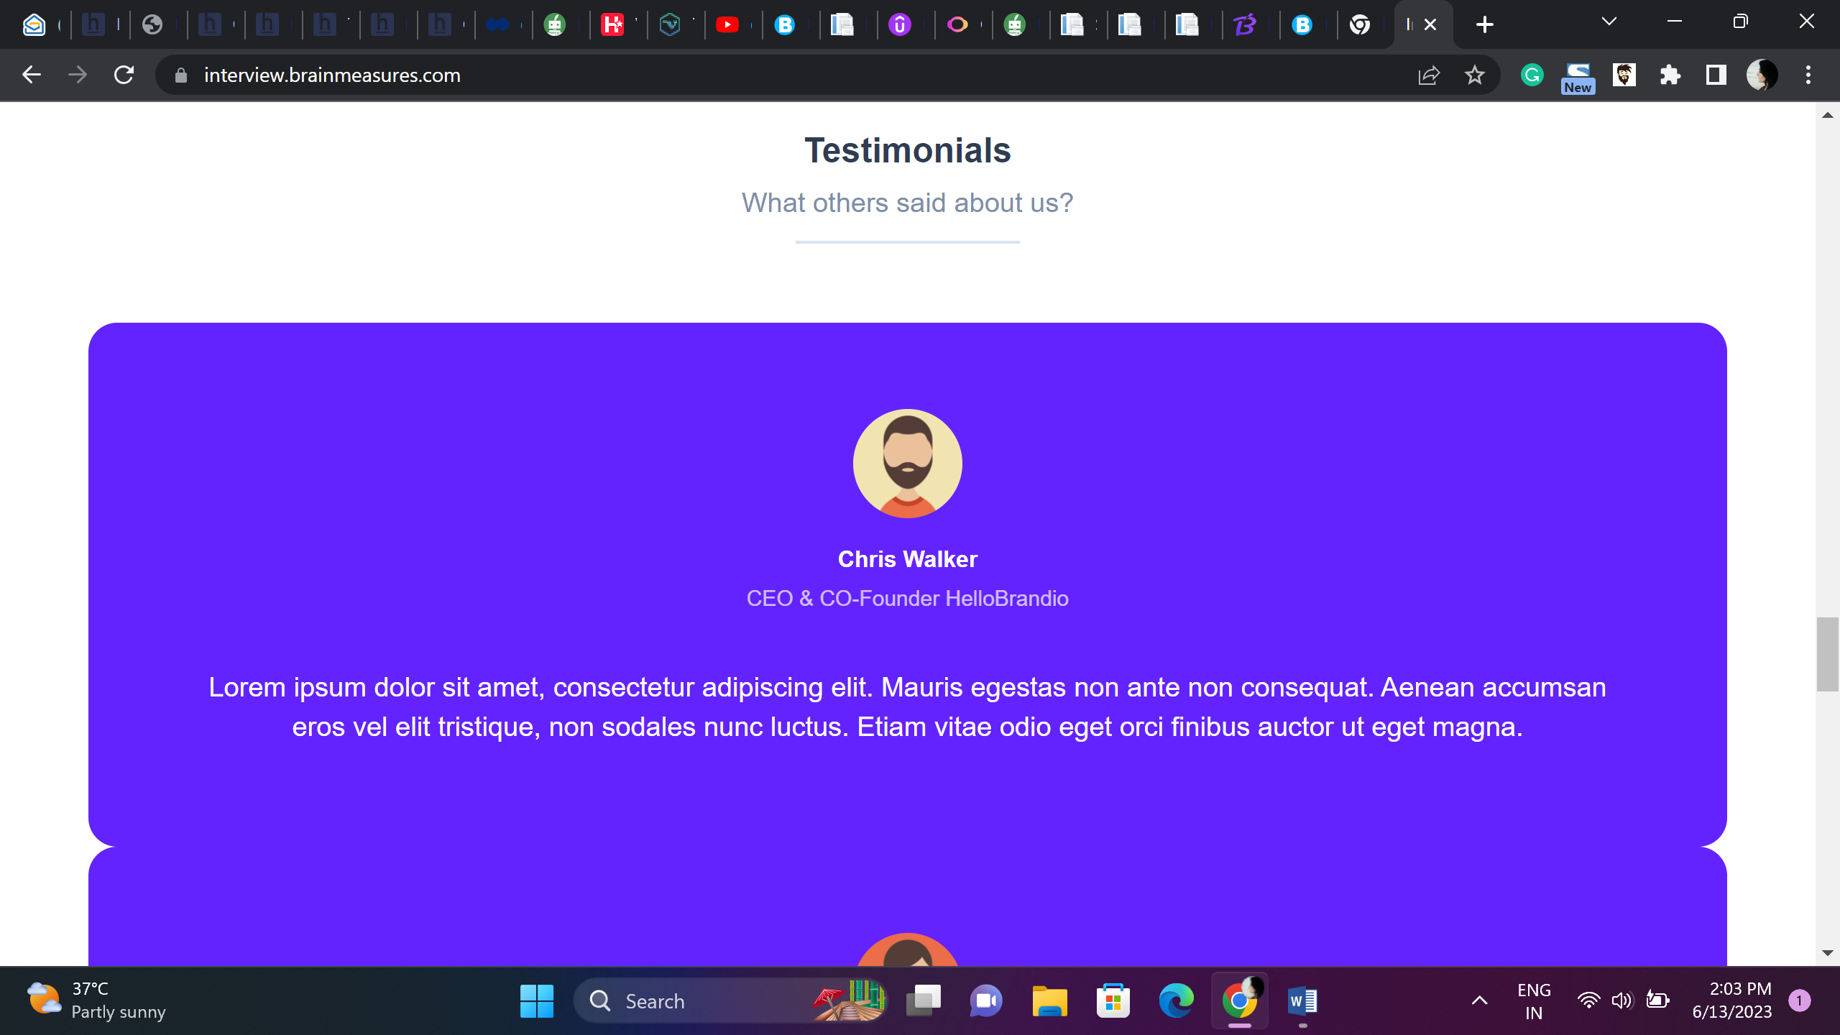

Testimonials

What are clients have to say about us?

**Daniel Walter**

**Hiring Manager, Wilma**

Brainmeasures Skill Assessment tools have been ideal fit for our organizations hiring needs. Its convenient, hassle free, customizable. I have managed to hire great talent using Brainmeasures.

Kwan

CEO, DigiWorld Solutions

Since we started working with Brainmeasures three years ago, they have been crucial in assisting us in scaling. Brainmeasures has met our needs for a very precise set of academic qualifications, including expertise in machine learning. George who has taken the time to get to know us and has brought individuals that are incredibly suitable, and I have a very strong relationship. We are eager to keep working together since we respect George’s consultative approach to meeting the interests of our company.

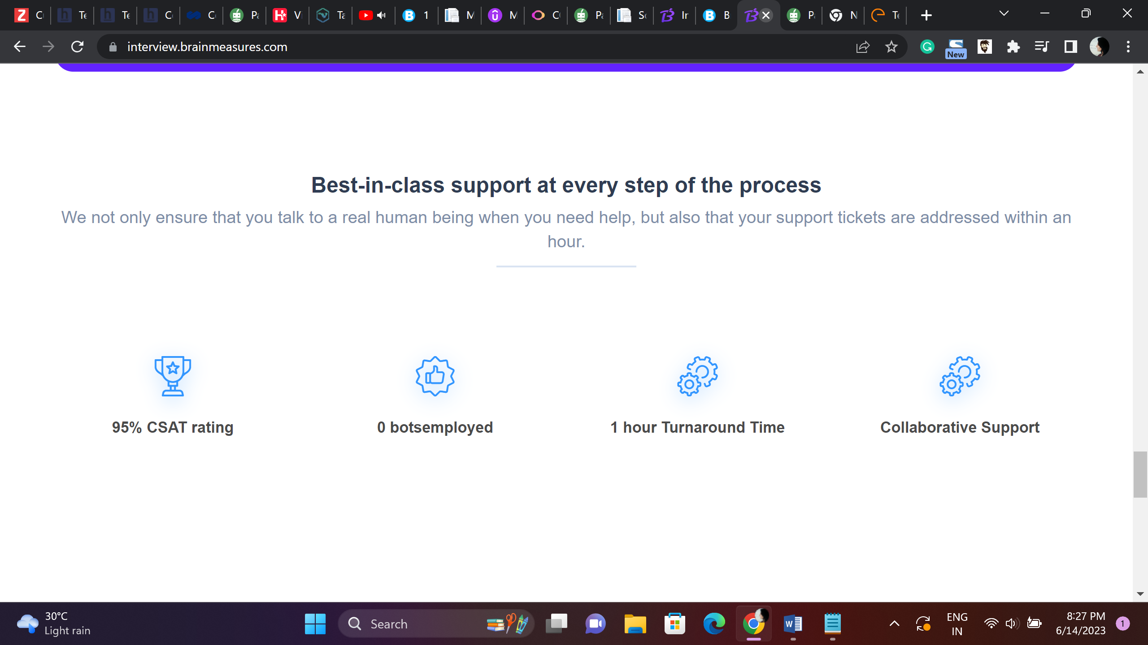

24X7 Customer Support

At Brainmeasures we understand that chatting with bots is the worst kind of customer support experience, no bots is Brainmeasures policy when customer support is involved, talk to real people who have been trained to handle any glitch customer faces along with that we have a wonderful email support with 2hour TAT

98% CSAT Rating – guaranteed customer Satisfaction

100% Human Chat Team – 0 Bots

2 Hour TAT – you don’t have to wait for 24 hours

Synergic Support

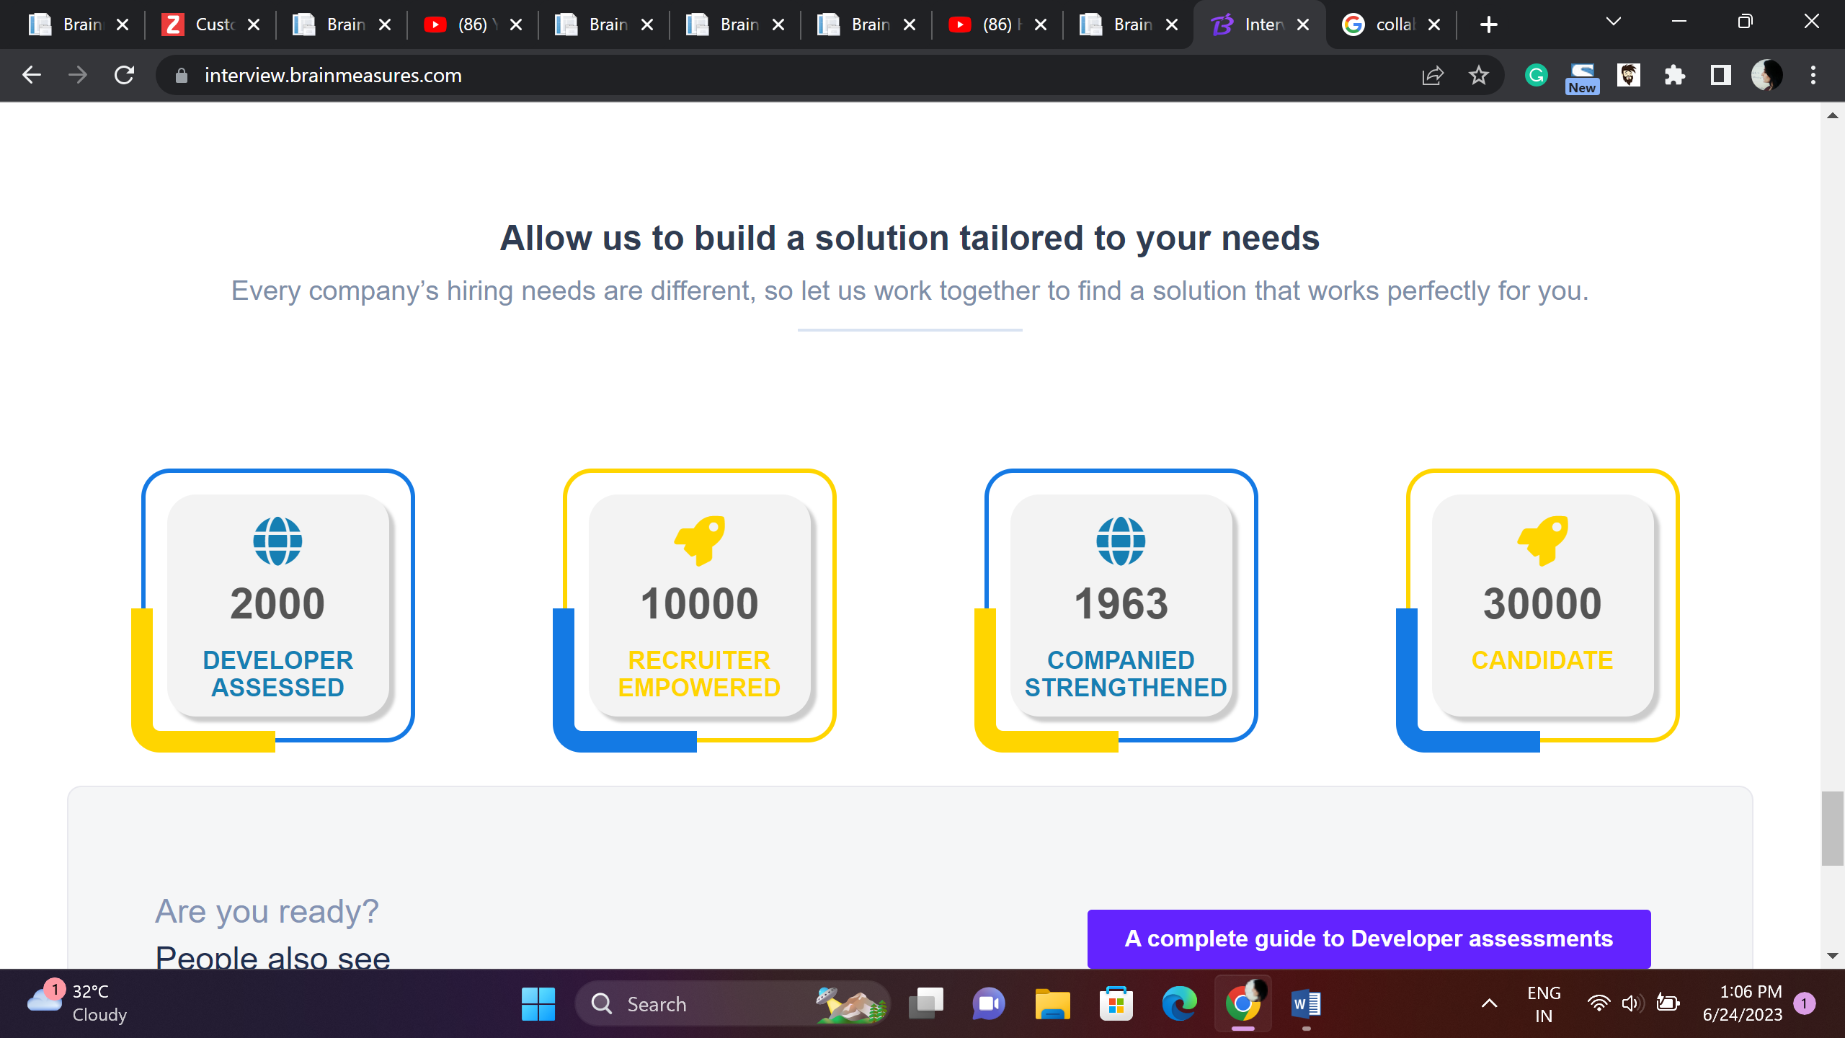

Customized Solutions – Customize our platform to meet your needs

Every organization has different goals so hiring needs cannot be same, choose Brainmeasures and get tailored solutions to meet your objectives.

2843

Companies using Brainmeasures

95000

Candidates Screened

47897

Developers Assessed using Brainmeasures Coding Platform

280000

Recruiters On-Board

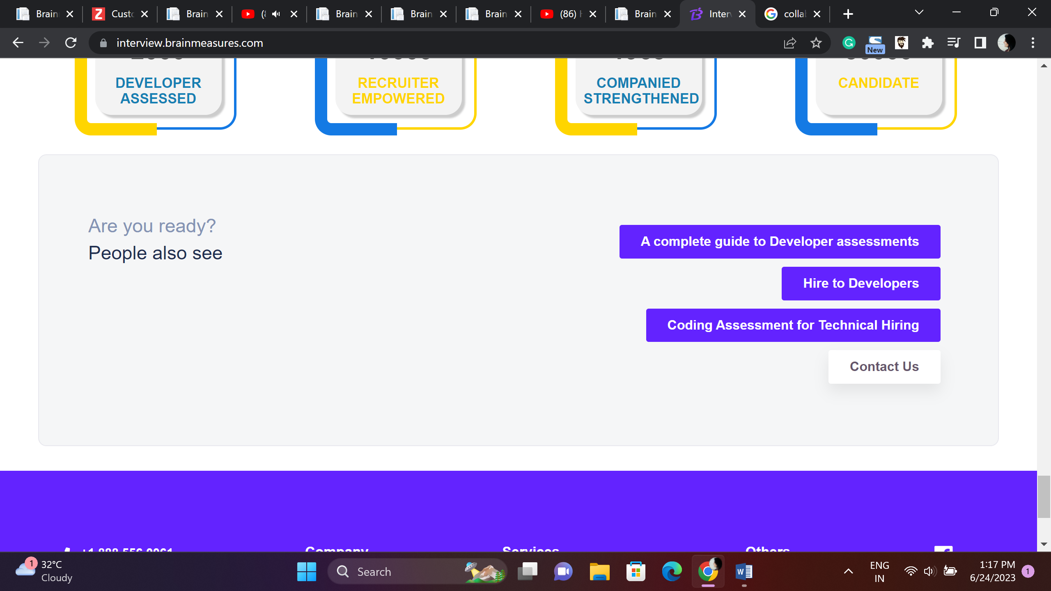

This content is OK

